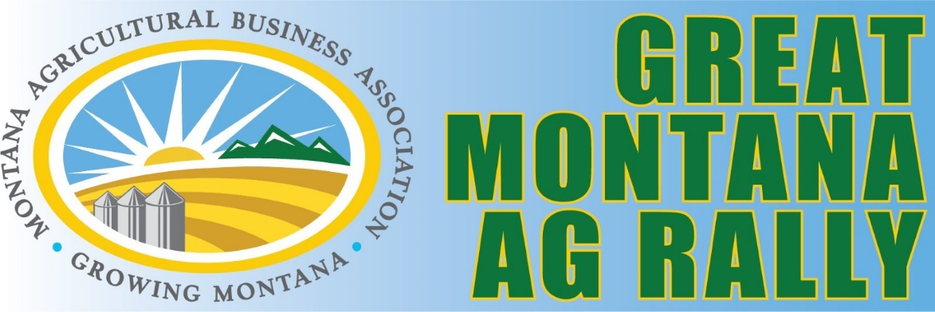

MABA

Great Montana Ag Rally

Golf Scramble

JULY 24, 2025

HICKORY SWINGS GOLF COURSE

You may register a four-man team or as an individual golfer.

PLEASE REGISTER ON OUR WEBSITE: https://www.mtagbiz.org/

We ask that each team have at least one MABA member.

Contact Name: ____________________________________________________
Contact Address: ____________________________________________________
____________________________________________________

Email: ____________________________________________________
Phone: ____________________________________________________

“GARAGE SALE”

Clean out the storage unit -- bring all of your leftover company marketing items to share with other golfers.

PRIZES will be awarded for:
- Most unique item
- Most retro item
- Nicest item

Team or Golfer Registration

Golf Team
Team Fee - $450.00
4 players, includes course fee, Golf Day breakfast and Golf Day lunch
Do you need a cart or carts?
Golf Cart Rental - $50.00
How many carts
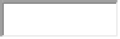
Individual Golfer
Individual Golfer - $150.00
includes course fee, Golf Day breakfast and Golf Day lunch

Team Name: _________________________________________________
Player #1: Name: __________________________Handicap _________ Player #2: Name: __________________________Handicap_________
Player #3: Name: __________________________Handicap _________ Player #4: Name: __________________________Handicap _________

Additional meals for guests
also available for purchase at the event
Golfer Registration includes all meals:
Breakfast – provided by – MABF
Lunch – Burgers at the Turn

PLEASE REGISTER ON OUR WEBSITE: https://www.mtagbiz.org/

Schedule of Events

July 24
7:30 AM – Breakfast Available at Clubhouse
8:00 AM – Rules and Shotgun Start
Midday – Lunch at the clubhouse at the turn
3:00 PM – Purse and Hole Prize Awards at the Clubhouse

